**Geometry Review**

**Homework Helper**

**\*Vocabulary and examples**

MGSE.4.G.1 Draw points, lines, line segments, rays, angles (right, acute, obtuse), and perpendicular and parallel lines. Identify these in two-dimensional figures

* **Points, Lines, Line Segments, & Rays**

Geometric terms can used to describe location and position.

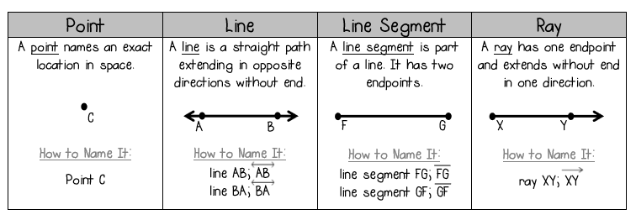

* **Angles**

An angle is formed by two rays or line segments that share the same endpoint. The common endpoint is called the vertex.

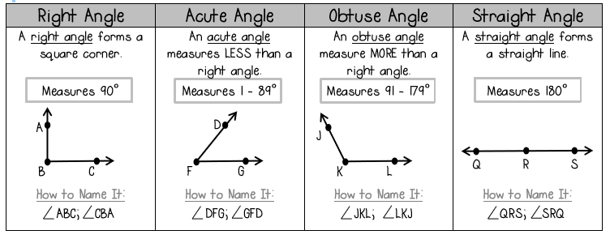

* **Lines**

Pairs of lines are given special names depending on their relationship.

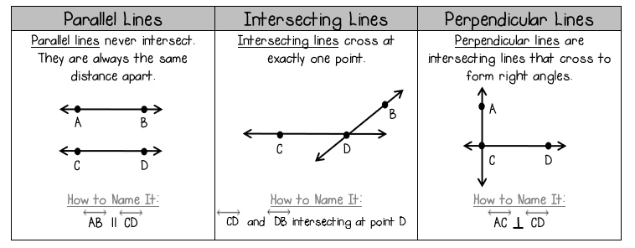

MGSE4.G.2 Classify two-dimensional figures based on the presence or absence of parallel or perpendicular lines, or the presence or absence of angles of a specified size. Recognize right triangles as a category, and identify right triangles.

* **Classify Triangles: Angles**

A triangle is any polygon with three sides and three angles. There are many types of triangles. One way triangles can be classified is by the measure of their angles.

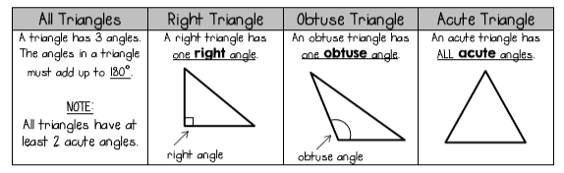

* **Classify Triangles: Sides**

A triangle is any polygon with three sides and three angles. There are many types of triangles. One way triangles can be classified is by their sides.

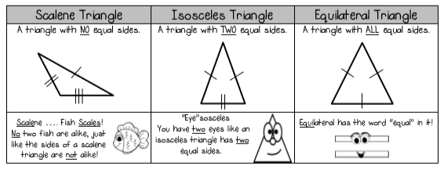

* **Classify Quadrilaterals**

A quadrilateral is any polygon with four sides and four angles. There are many types of quadrilaterals.

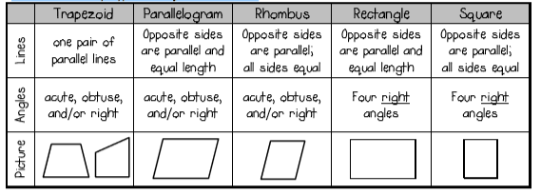

MGSE4.G.3 Recognize a line of symmetry for a two-dimensional figure as a line across the figure such that the figure can be folded along the line into matching parts. Identify line-symmetric figures and draw lines of symmetry.

* **Line Symmetric Figures**

A figure is line symmetric if it can be folded over a line so that one half of the figure matches the other half of the figure. This line is called a line of symmetry.

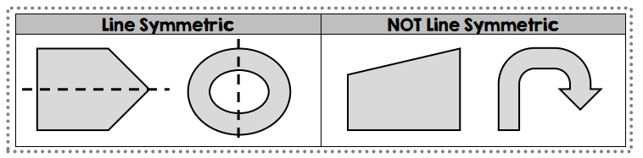

* **Identify Lines of Symmetry**

A line of symmetry divides a figure so that one half of the figure matches the other half of the figure.

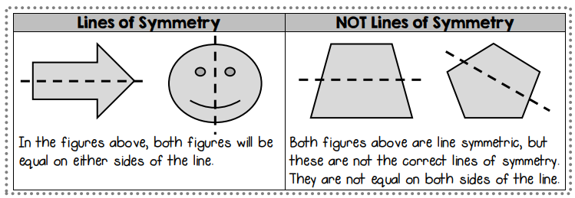

* **Multiple Lines of Symmetry**

Many figures have more than one line of symmetry. When trying to identify lines of symmetry, remember lines can be horizontal, vertical, or diagonal. Notice in the examples below how all lines of symmetry cross at a center point.

